Drill motor, corded and battery These tools are taught in the Getting Started class.
Inspect tool for hazards.
Inspect the floor for debris.
Unplug or remove battery before making any changes.
Clamp work to the bench.
PPE, wear eye protection.
If you can’t see both hands, don’t turn the tool on.
Let the tool do the work. Don’t force the action.

Jigsaw
Inspect tool for hazards.
Inspect the floor for debris.
Unplug or remove battery before making any changes.
Clamp workpiece to the bench.
PPE, eye and ear protection are required for this tool.
If you can’t see both hands, don’t turn the tool on.
Choose blade appropriate for the material.
Let the tool do the work. Don’t force the action.

Trim Router
Inspect tool for hazards.
Inspect the floor for debris.
Unplug or remove battery before making any changes.
Clamp work to the bench.
PPE, eye and ear protection are required for this tool.
If you can’t see both hands, don’t turn the tool on.
Let the tool do the work. Don’t force the action.
Use small round over profiles or flush trim bits.
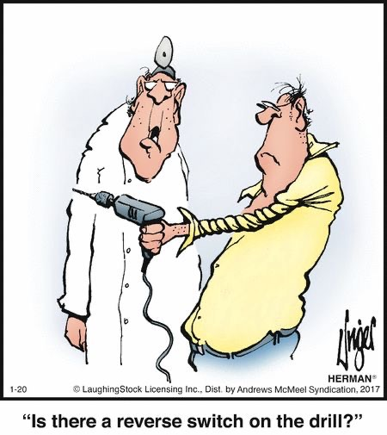
Random orbital sander
Inspect tool for hazards.
Inspect the floor for debris.
Unplug or remove battery before making any changes.
PPE, eye and ear protection are required for this tool.
Clamp work to the bench
If you can’t see both hands, don’t turn the tool on.
Connect to dust collection.
Let the tool do the work.
Don’t force the action with downward pressure.
Guide sanding motion parallel to grain.
Use sharp sandpaper.

Circular saw
Inspect tool and blade for hazards.
Inspect the floor for debris.
Unplug or remove battery before making any changes.
Test all guards for easy motion and complete closure.
Secure both shoe adjustment knobs/levers.
Do not use your body as a saw horse.
Clamp workpiece to the bench.
If you can’t see both hands, don’t turn the tool on.
Let the tool do the work. Don’t force the action.
Use both hands to guide the tool.
PPE, including eye and ear protection are required for this tool.
Review the complete safety manual for this tool.

January 14, 2021

